

**LET’S CELEBRATE**

**ZAINAB’S BIRTHDAY**





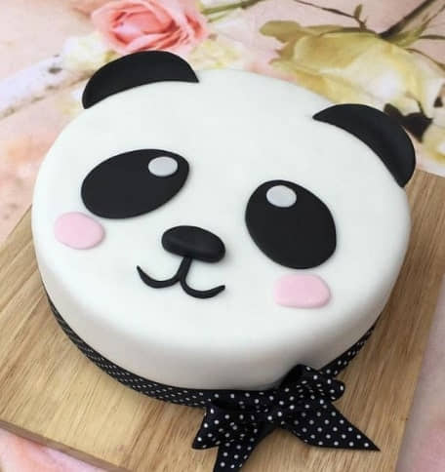

**On**

**Saturday Jan 1 2022**

**At**

**Pizza hut**

**Fun Republic mall**

**2nd floor**

10

**LIST OF ITEMS REQUIRED FOR A BIRTHDAY PARTY**

DECORATIONS

STREAMERS

BALLOONS

BIRTHDAY BANNER

PANDA THEMED CUTOUTS

PARTY HATS

FOOD

CAKES

BURGER (VEG)

JUICES

CHIPS

PIZZAS AND GARLIC BREADS